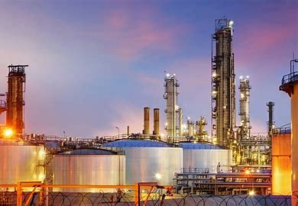
Oil & Gas Industry

# Global 5000 companies | 245
Total Industry Revenue | $6.5 trillion
Industry employees | 6,203,548
5 year Growth Rate | neg 3.3%
Revenue per employee | $1,052,404

Top 10 Global Oil & Gas Companies
- Sinopec Group (China Petroleum & Chemical)
- China National Petroleum
- Royal Dutch Shell Group
- Saudi Arabian Oil Company (Aramco)
- BP plc
- Exxon Mobil Corporation
- Vitol Holding B.V.
- Total S.A.
- Chevron Corporation
- Rosneft Oil

